Pass for level 23:

Step 1: Login to natas 22

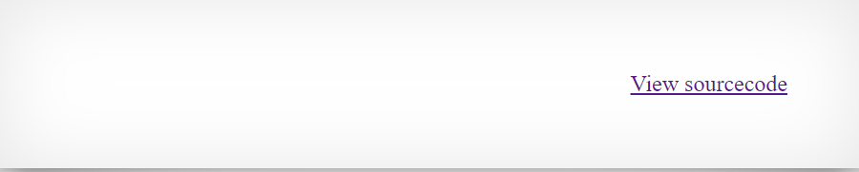

Step 2: View source code

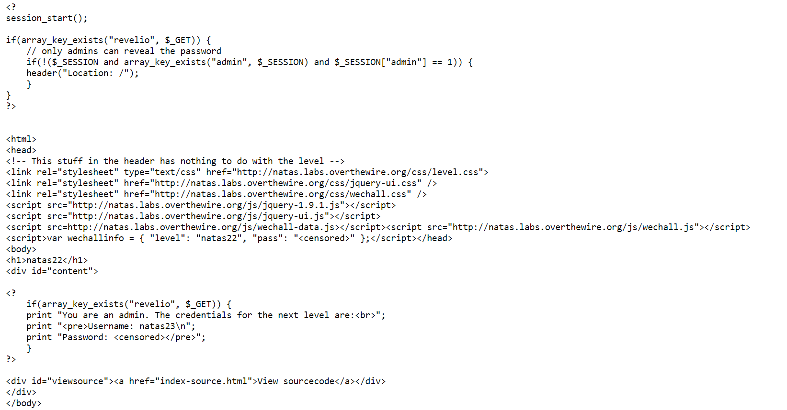

It starts the session and then check if I am admin otherwise it redirect me

The second php code check if I have "revelio" variable in the get requests then it will send the credentials.

Step 3:

Entering <http://natas22.natas.labs.overthewire.org/?revelio=true>

And disallow redirections and them I will apply the php code inside the website.

